***Computer Programming***

***Csl-113***

***Lab Journal***



**Muhammad Wajahat**

**01-134192-102**

**BS(CS)-1B**

**Department of Computer Science**

**BAHRIA UNIVERSITY, ISLAMABAD**

**Lab # 12:**

**Objectives:**

**To learn about pointers**

**Tools Used:**

**Visual Studio 2015**

**Submission Date:**

**Evaluation: Signatures of Lab Engineer:**

**Task # 1:**

Write the output of following code.

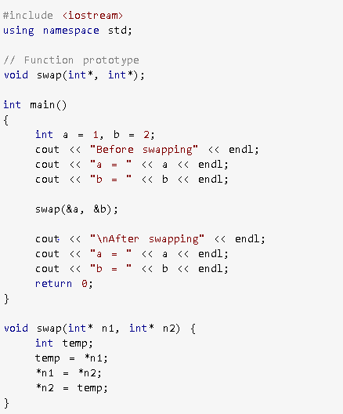

**Result/Output:**

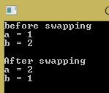

**Task # 2:**

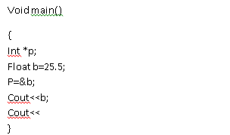

**Result/Output:**

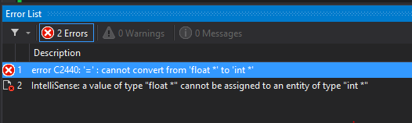

**Task # 3:**

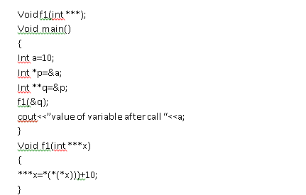

**Result/Output:**

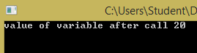

**Task # 4:**

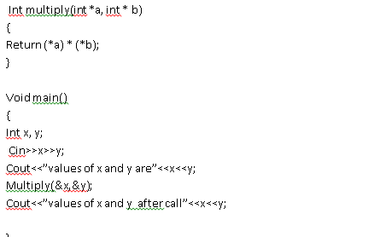

**Result/Output:**

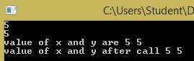

**Task # 5:**

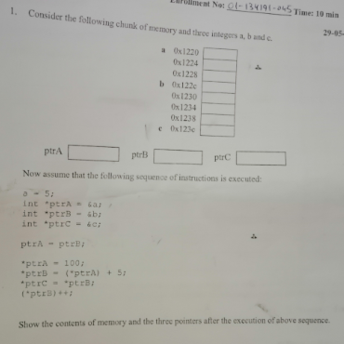

**Result/Output:**

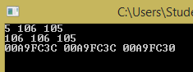

**Task # 6:**

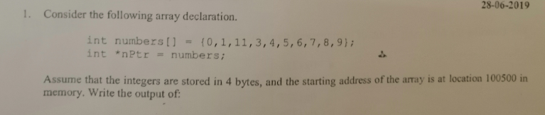

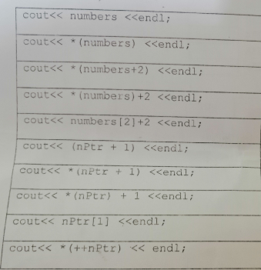

**Result/Output:**

